1. Name the 3 states of matter and a water example of each.
State_________________ Example _________________
State_________________ Example _________________
State_________________ Example _________________

2. ADD HEAT to a SOLID to make it a ___________.
ADD HEAT to a LIQUID to make it a __________.

3. COOL a gas to make it a _______________.
COOL a liquid to make it a _____________.

4. Correctly label the water cycle.

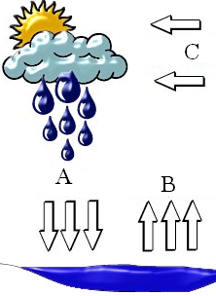

5. Water is returned to the earth by rain, sleet, snow, or hail _____________.
Heat from the sun makes water rise __________________.
Air cools and the water vapor forms clouds _________________.

6. What effects how quickly water evaporates?
___________________________________________________________
___________________________________________________________
___________________________________________________________

7. Water vapor in the air is called ___________ and measured with a
______________.
The speed of the wind is measured with a ________________________.
The direction of the wind is measured with a ______________________.
How hot or cold it is, is called the ________________ and is measured with a
_____________________.
How hard the air presses down is called _____________________ and is
measured with a ___________________.

8. What is the difference between weather and climate? _____________________
________________________________________________________________
________________________________________________________________
9. How often does the weather change? __________________________________
________________________________________________________________

10. A prediction about what the weather will be like in the future is called a
_________________.

11. What is the weather like in Mayfield today? What will it be like tomorrow?
How do you know that?

